MATLAB ASSIGNMENT

LINEAR ALGEBRA

UE20MA251

NON IN-BUILT FUNCTION PROGRAMS:

1. GAUSS ELIMINATION METHOD:

I) X+2y-z=3,2x+y-2z=3,-3x+y+z=-6

C = [1 2 -1; 2 1 -2; -3 1 1]  
b= [3 3 -6]'  
A = [C b];   
n= size(A,1);   
x = zeros(n,1);

for i=1:n-1  
for j=i+1:n  
m = A(j,i)/A(i,i)  
A(j,:) = A(j,:) - m*A(i,:)  
end  
end

x(n) = A(n,n+1)/A(n,n)  
for i=n-1:-1:1  
summ = 0  
for j=i+1:n  
summ = summ + A(i,j)*x(j,:)  
x(i,:) = (A(i,n+1) - summ)/A(i,i)  
end  
end

Output:  
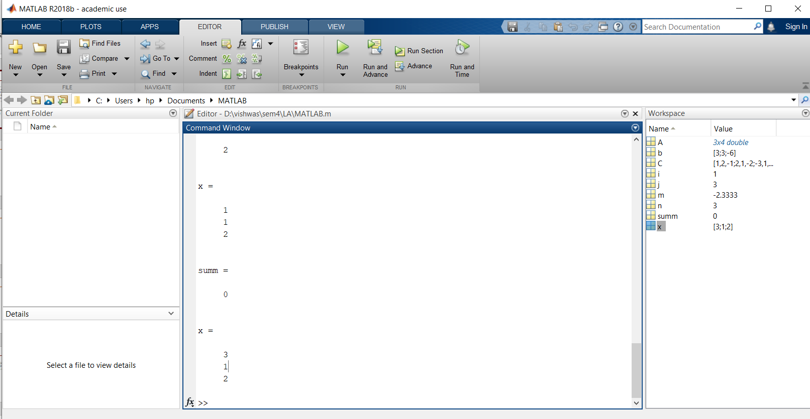

ii) x+y+z=11,2x-6y-1z=0,-3x+4y+2z=-0

C = [1 1 1; 2 -6 -1; 3 4 2]  
b= [11 0 0]'  
A = [C b];   
n= size(A,1);   
x = zeros(n,1);

for i=1:n-1  
for j=i+1:n  
m = A(j,i)/A(i,i)  
A(j,:) = A(j,:) - m*A(i,:)  
end  
end

x(n) = A(n,n+1)/A(n,n)  
for i=n-1:-1:1  
summ = 0  
for j=i+1:n  
summ = summ + A(i,j)*x(j,:)  
x(i,:) = (A(i,n+1) - summ)/A(i,i)  
end  
end

Output :

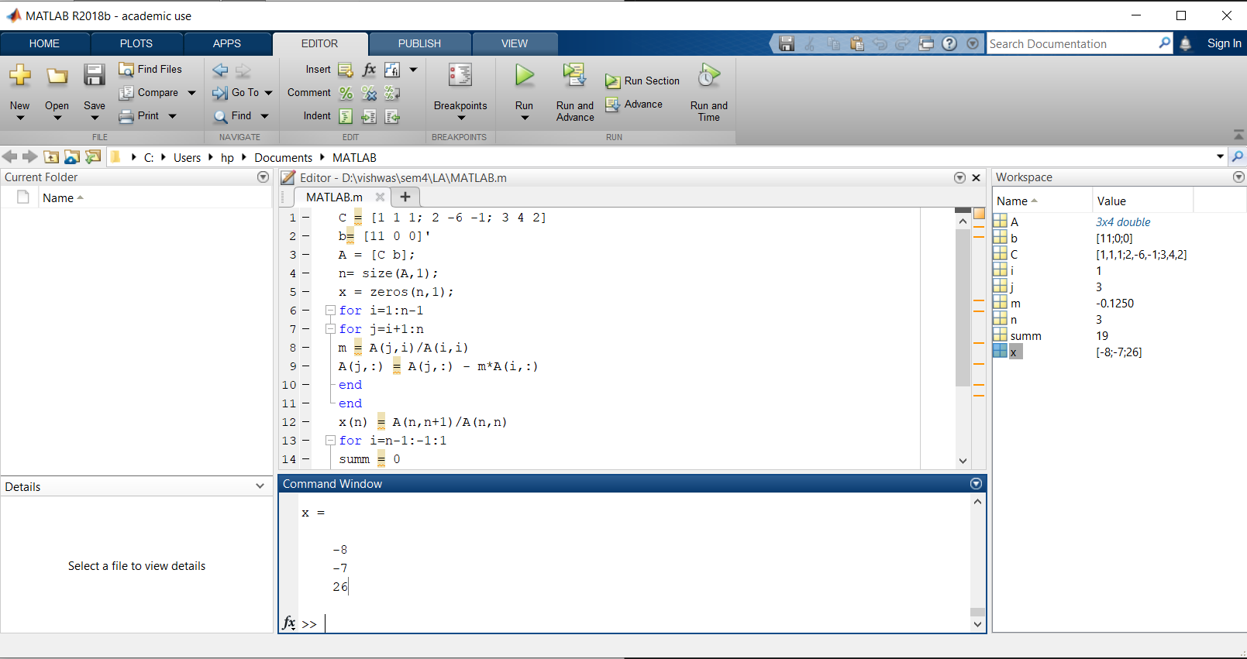

iii) 2x+y-z=0,2x+5y+7z=52,x+y+z=-9

C = [2 1 -1; 2 5 7; 1 1 1  
b= [0 52 9]’

A = [C b];   
n= size(A,1);   
x = zeros(n,1);

for i=1:n-1  
for j=i+1:n  
m = A(j,i)/A(i,i)  
A(j,:) = A(j,:) - m*A(i,:)  
end  
end

x(n) = A(n,n+1)/A(n,n)  
for i=n-1:-1:1  
summ = 0  
for j=i+1:n  
summ = summ + A(i,j)*x(j,:)  
x(i,:) = (A(i,n+1) - summ)/A(i,i)  
end  
end

Output:

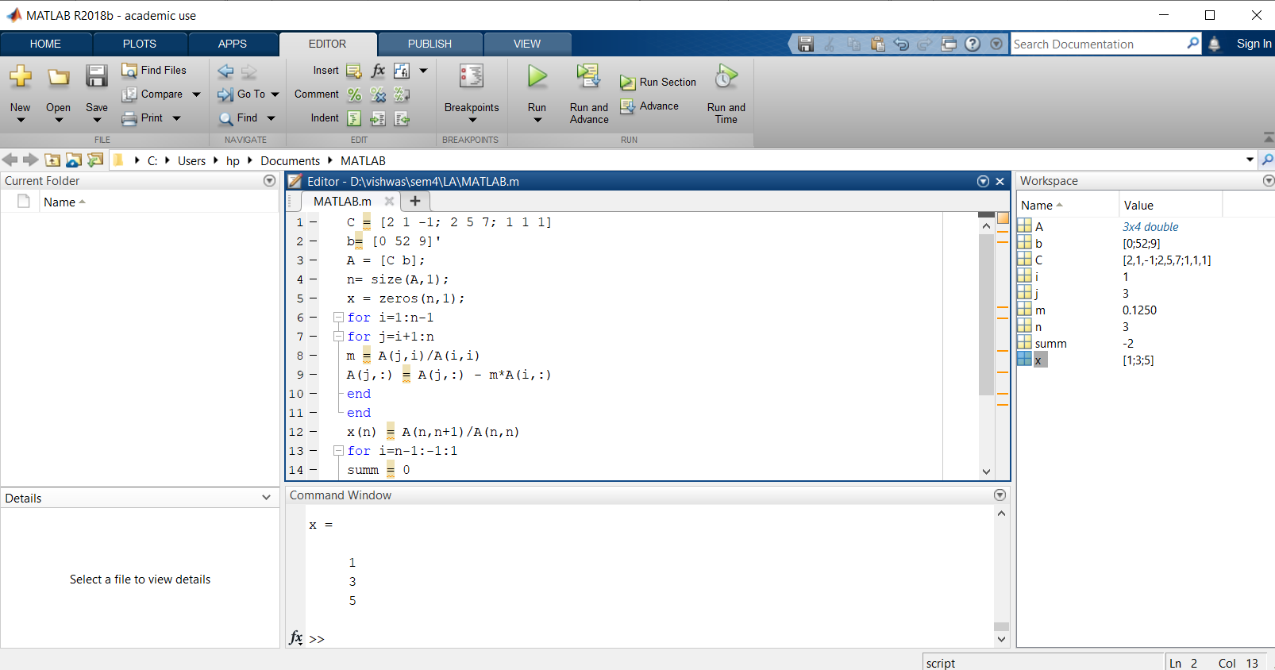

1. **Gauss - Jordan Method To find Inverse:**

I)Find by Gauss Jordan Method

A =[1,1,1;4,3,-1;3,5,3];

n =length(A(1,:));

Aug =[A,eye(n,n)]

for j=1:n-1

for i=j+1:n

Aug(i,j:2*n)=Aug(i,j:2*n)-Aug(i,j)/Aug(j,j)*Aug(j,j:2*n)

end

end

for j=n:-1:2

Aug(1:j1,:)=Aug(1:j1,:)Aug(1:j1,j)/Aug(j,j)*Aug(j,:)

end

for j=1:n

Aug(j,:)=Aug(j,:)/Aug(j,j)

end

B=Aug(:,n+1:2*n)

Output:

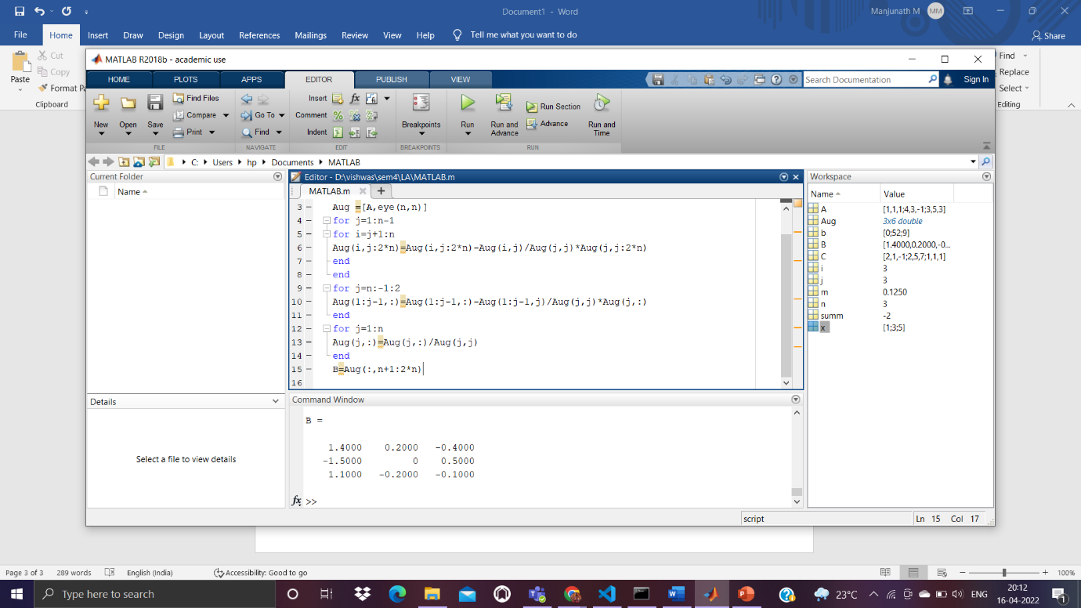

ii)Find by Gauss Jordan Method

A =[1,4,1;1,2,1;1,8,5];

n =length(A(1,:));

Aug =[A,eye(n,n)]

for j=1:n-1

for i=j+1:n

Aug(i,j:2*n)=Aug(i,j:2*n)-Aug(i,j)/Aug(j,j)*Aug(j,j:2*n)

end

end

for j=n:-1:2

Aug(1:j1,:)=Aug(1:j1,:)Aug(1:j1,j)/Aug(j,j)*Aug(j,:)

end

for j=1:n

Aug(j,:)=Aug(j,:)/Aug(j,j)

end

B=Aug(:,n+1:2*n)

Output:

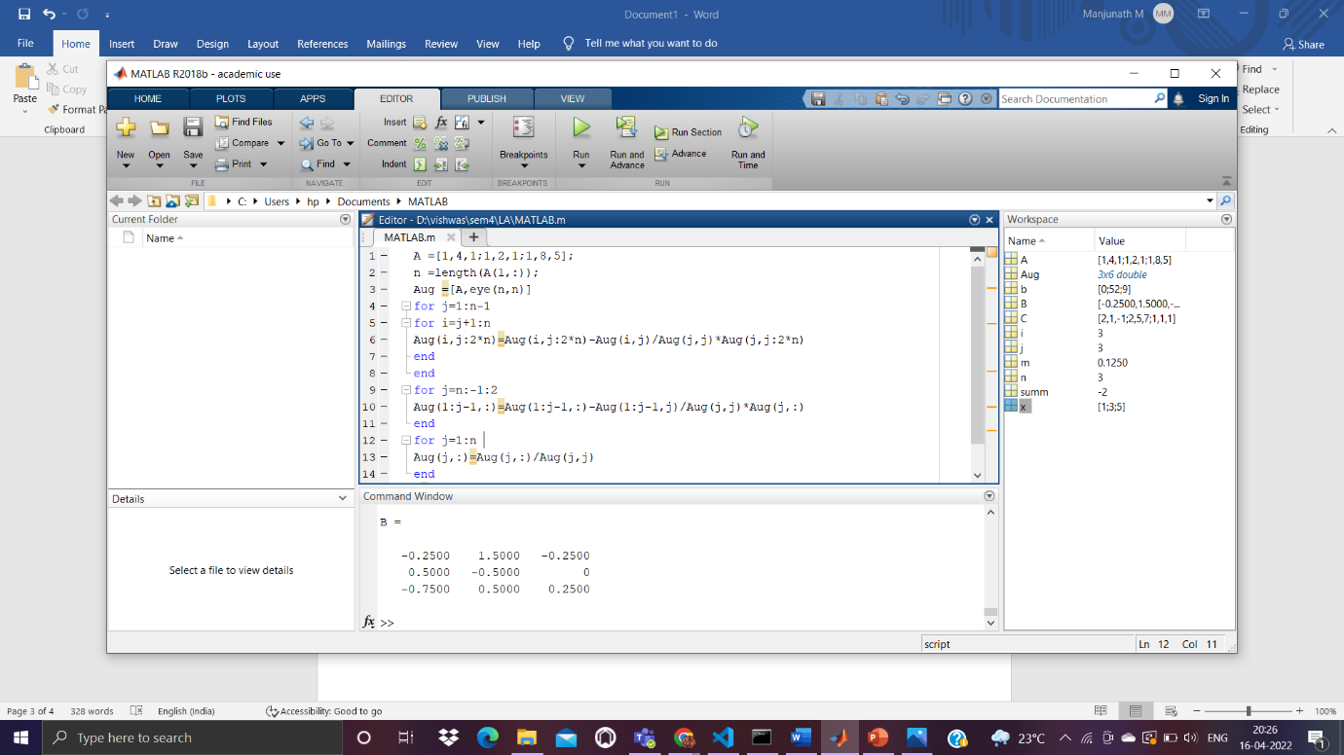iii) Find by Gauss Jordan Method

A =[-1,2,6;-1,-2,4;-1,1,5];

n =length(A(1,:));

Aug =[A,eye(n,n)]

for j=1:n-1

for i=j+1:n

Aug(i,j:2*n)=Aug(i,j:2*n)-Aug(i,j)/Aug(j,j)*Aug(j,j:2*n)

end

end

for j=n:-1:2

Aug(1:j1,:)=Aug(1:j1,:)Aug(1:j1,j)/Aug(j,j)*Aug(j,:)

end

for j=1:n

Aug(j,:)=Aug(j,:)/Aug(j,j)

end

B=Aug(:,n+1:2*n)

Output:

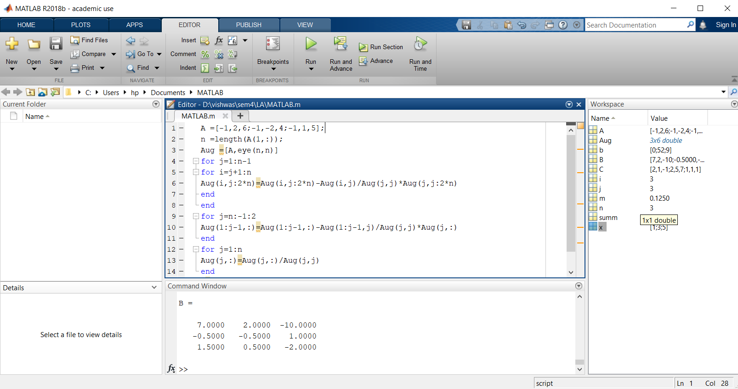

1. **LU Decomposition Method:**

I)

Ab = [1 1 -1;3 5 6;7 8 9];

n= length(A);

L = eye(n);

for i =2:3

alpha = Ab(i,1)/Ab(1,1);

L(i,1) = alpha;

Ab(i,:) = Ab(i,:) - alpha*Ab(1,:);

end

i=3;

alpha = Ab(i,2)/Ab(2,2);

L(i,2) = alpha

Ab(i,:) = Ab(i,:) - alpha*Ab(2,:);

U = Ab(1:n,1:n)

Output:

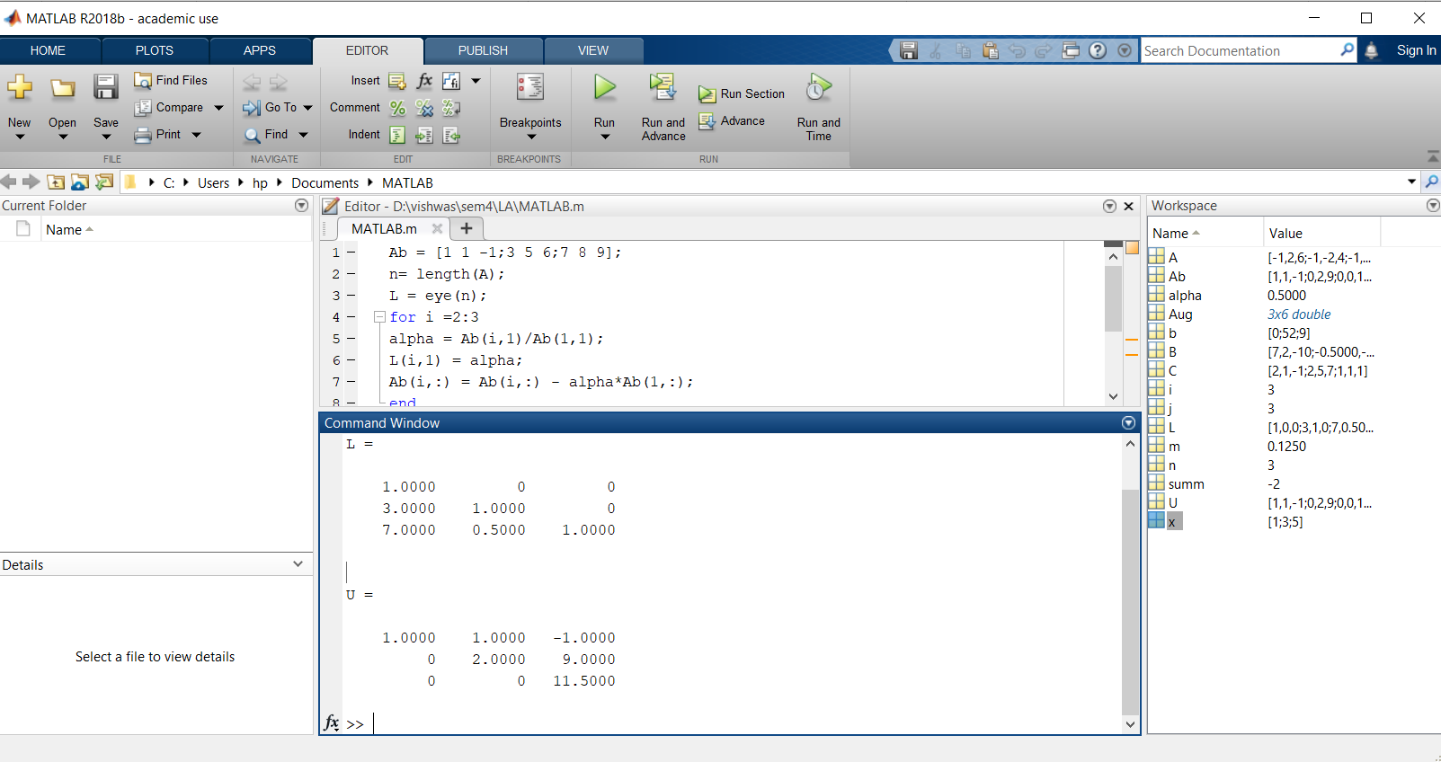ii)

Ab = [1 1 3;1 2 4;1 1 5];

n= length(A);

L = eye(n);

for i =2:3

alpha = Ab(i,1)/Ab(1,1);

L(i,1) = alpha;

Ab(i,:) = Ab(i,:) - alpha*Ab(1,:);

end

i=3;

alpha = Ab(i,2)/Ab(2,2);

L(i,2) = alpha

Ab(i,:) = Ab(i,:) - alpha*Ab(2,:);

U = Ab(1:n,1:n)

Output:

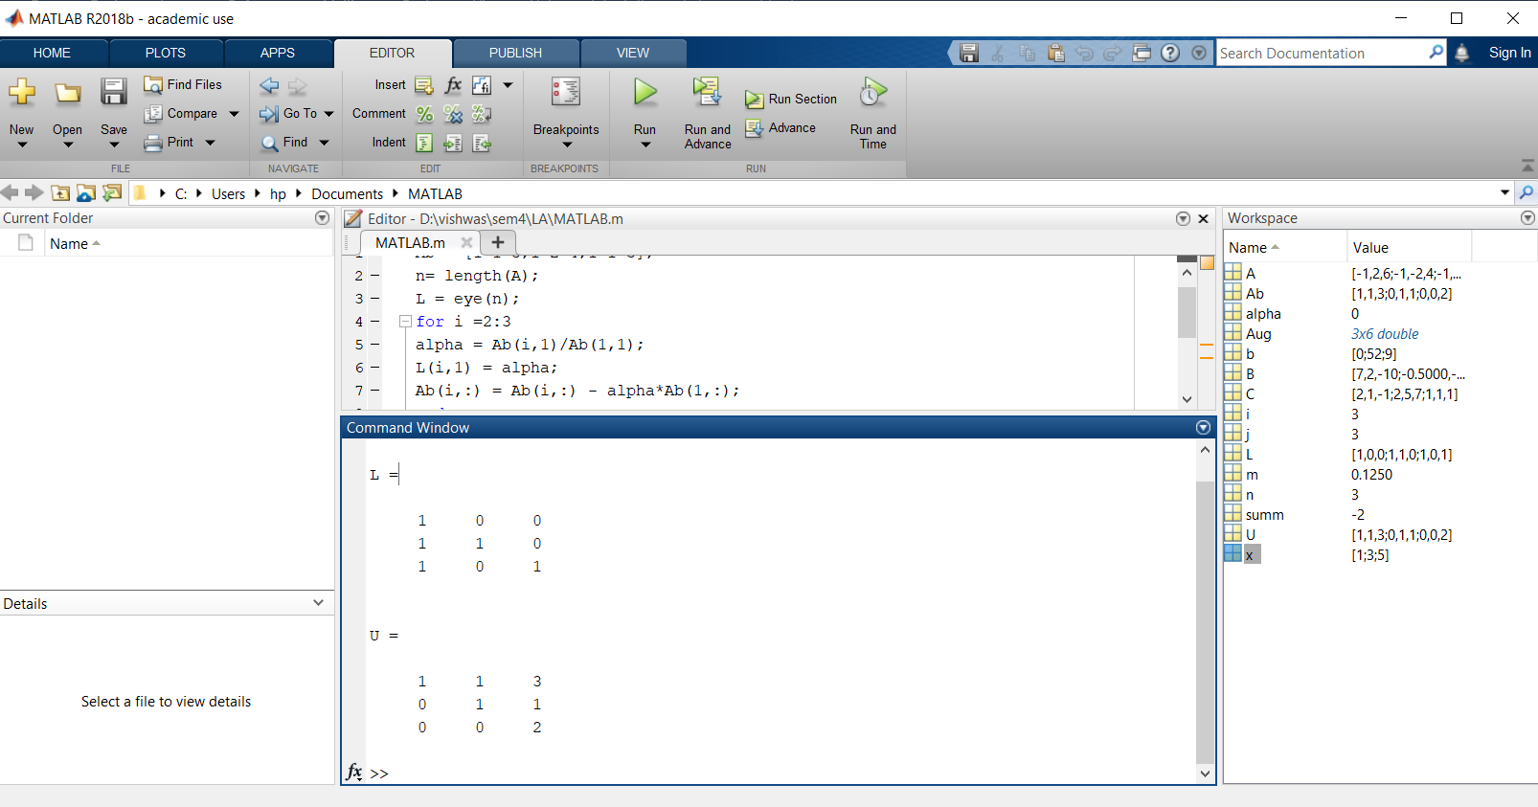

iii)

Ab = [-1 4 6;0 -2 4;0 0 5];

n= length(A);

L = eye(n);

for i =2:3

alpha = Ab(i,1)/Ab(1,1);

L(i,1) = alpha;

Ab(i,:) = Ab(i,:) - alpha*Ab(1,:);

end

i=3;

alpha = Ab(i,2)/Ab(2,2);

L(i,2) = alpha

Ab(i,:) = Ab(i,:) - alpha*Ab(2,:);

U = Ab(1:n,1:n)

Output:

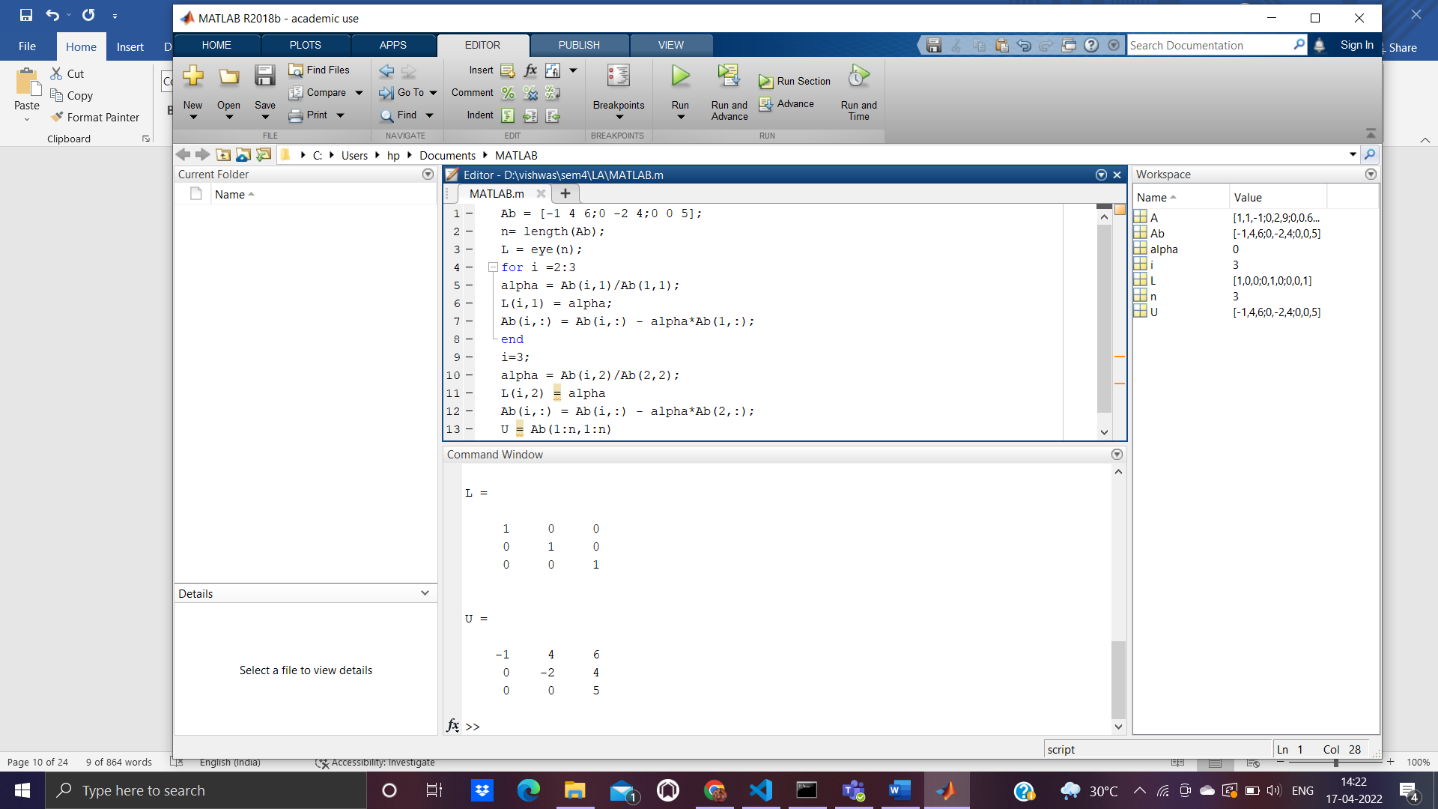

1. Grams- Schmidt Orthogonalization process:
2. Apply the Gram-Schmidt process to the vectors (1,0,1), (1,0,0) and (2,1,0) to produce a set of Orthonormal vectors.

A=[1,1,2;0,0,1;1,0,0]

Q=zeros(3)

R=zeros(3)

for j=1:3

v=A(: , j)

for i=1:j-1

R(i,j)=Q(:,i)'*A(:,j)

v=v-R(i,j)*Q(:,i)

end

R(j,j)=norm(v)

Q(:,j)=v/R(j,j)

end

Output:

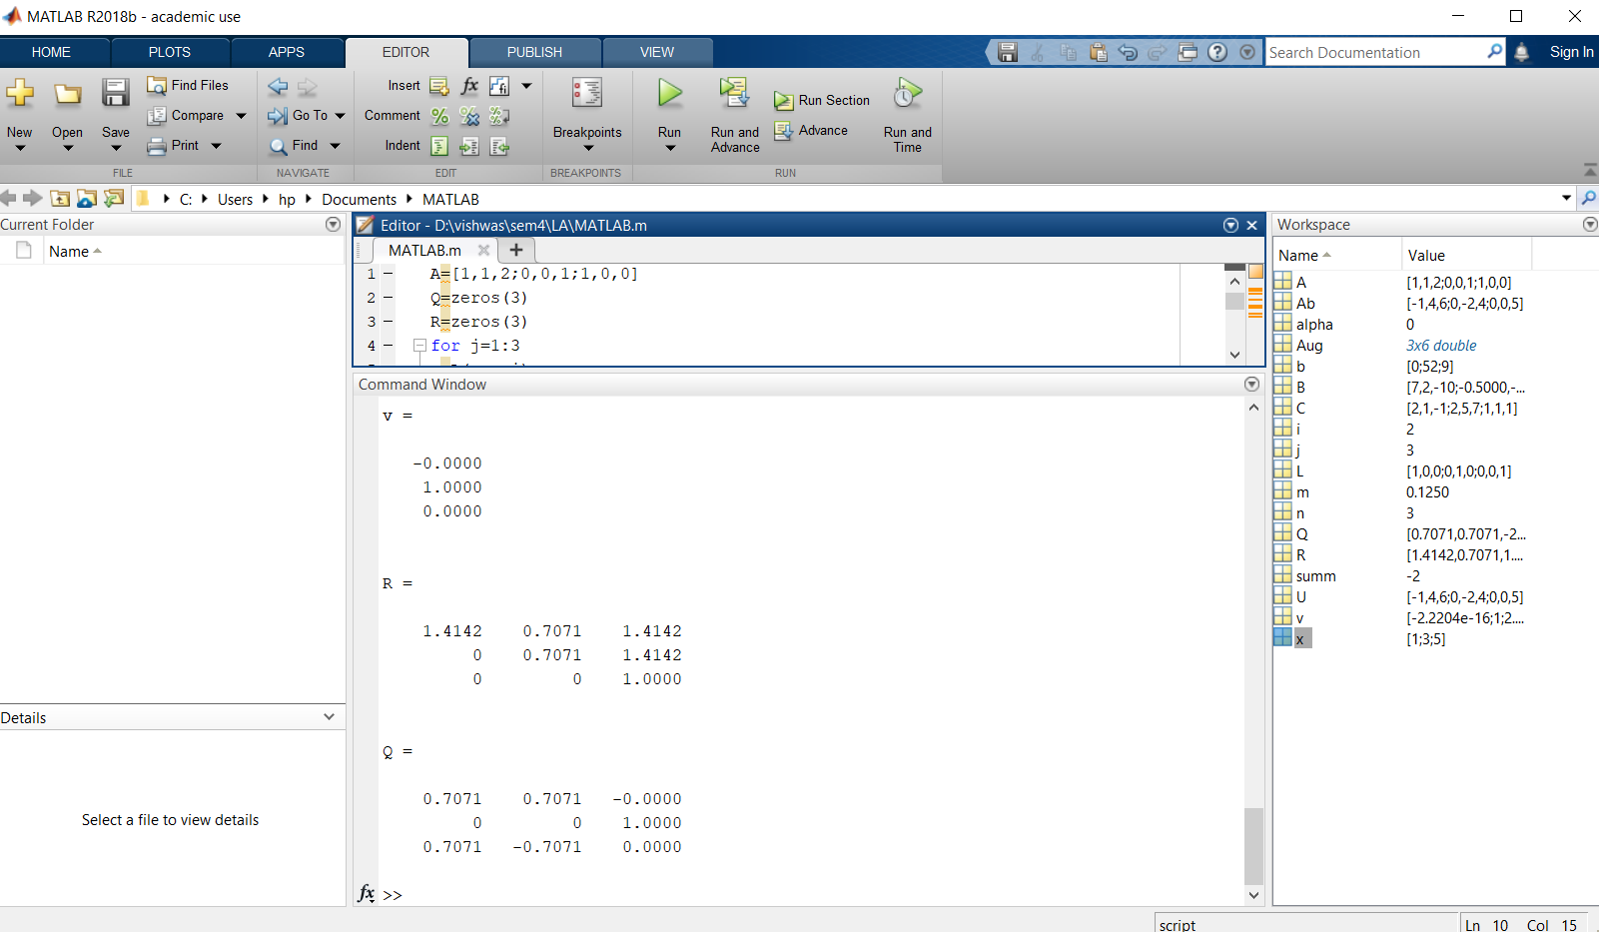

ii)Apply the Gram-Schmidt process to the vectors a=(0,1,1,1), b=(1,1,-1,0) and c=(1,0,2,-1).

A=[0,1,1;1,1,0;1,-1,2;1,0,-1]

Q=zeros(4,3)

R=zeros(3)

for j=1:3

v=A(: , j)

for i=1:j-1

R(i,j)=Q(:,i)'*A(:,j)

v=v-R(i,j)*Q(:,i)

end

R(j,j)=norm(v)

Q(:,j)=v/R(j,j)

end

Output:

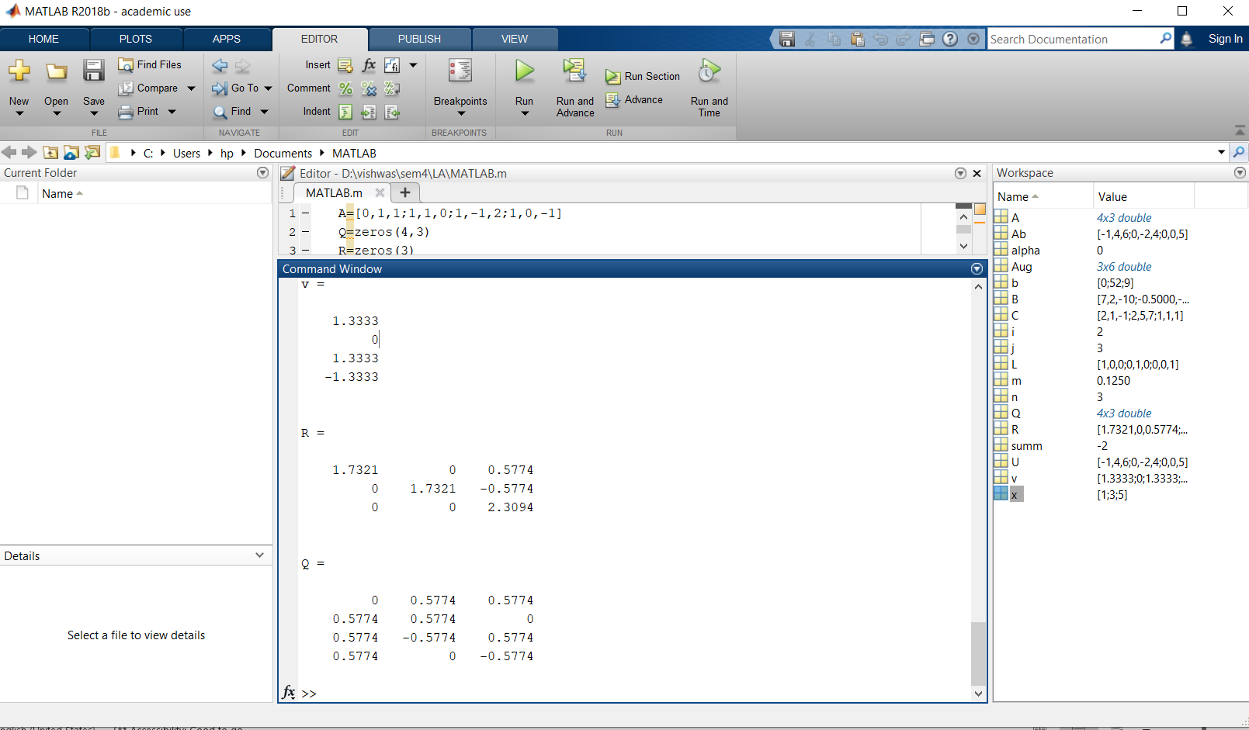

iii)Apply the Gram-Schmidt process to the vectors a=(0,1,1,1), b=(1,1,-1,0) and c=(1,0,2,-1).

A=[2,2,1;1,-1,0;3,-1,-2;1,3,-1]

Q=zeros(4,3)

R=zeros(3)

for j=1:3

v=A(: , j)

for i=1:j-1

R(i,j)=Q(:,i)'*A(:,j)

v=v-R(i,j)*Q(:,i)

end

R(j,j)=norm(v)

Q(:,j)=v/R(j,j)

end

Output:

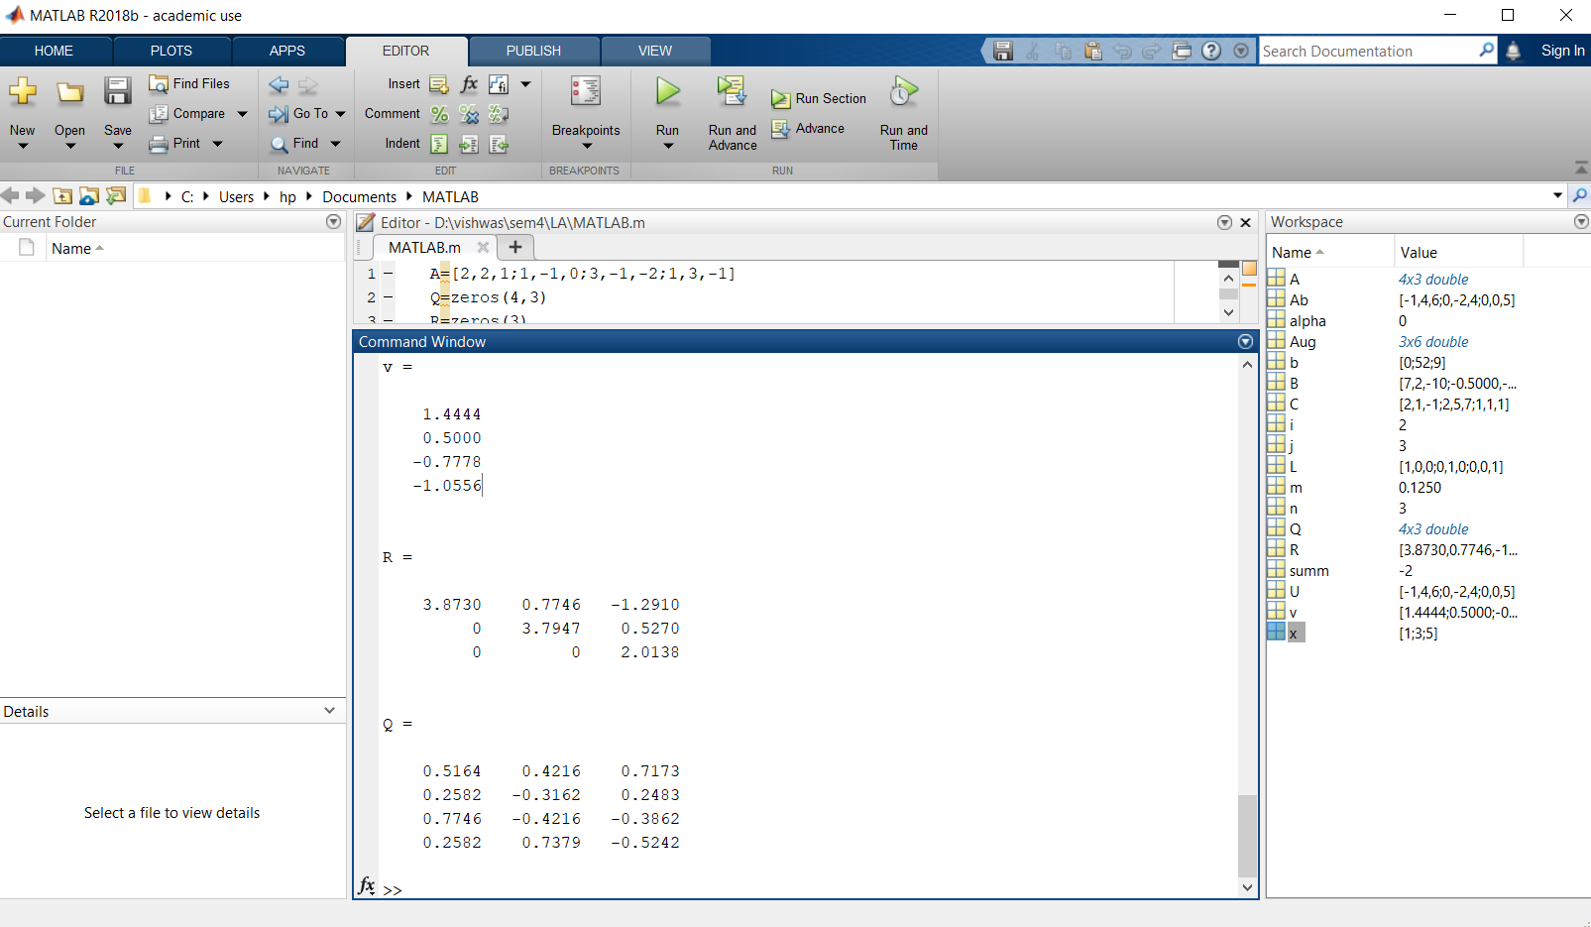

**In-Built Functions:**

1. **Projection matrices:**

i)Find the projection for the matrix  *,*

A=[1,0;0,1;1,1]

b=[1;3;4]

x = lsqr(A,b)

Output:

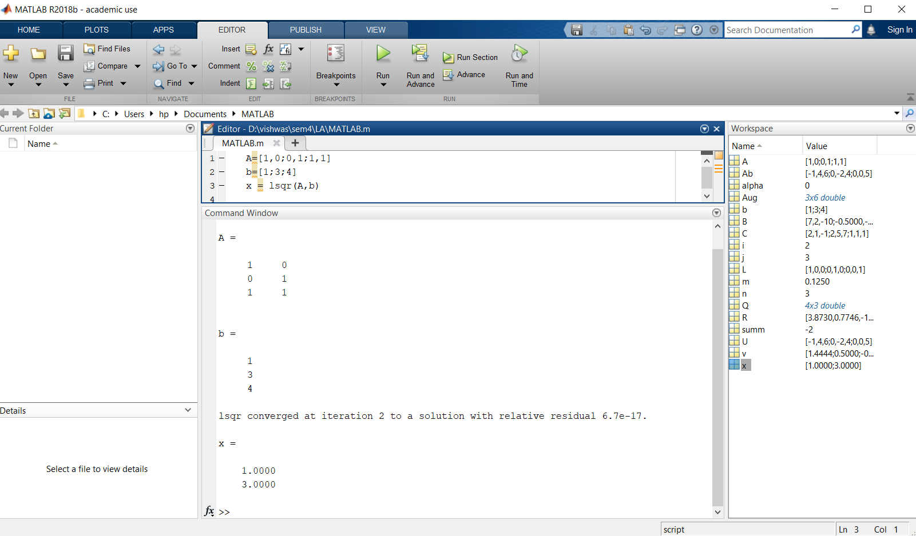

ii)Find the projection for the matrix  *,*

A=[1,1;1,0;0,1]

b=[1;2;3]

x = lsqr(A,b)

Output:

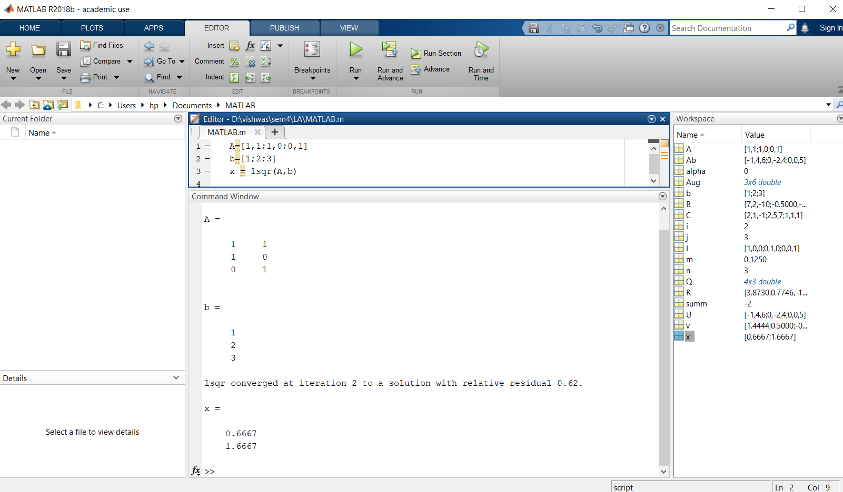iii) Find the projection for the matrix  *,*

A=[1,2;1,5;7,1]

b=[2;4;5]

x = lsqr(A,b)

Output:

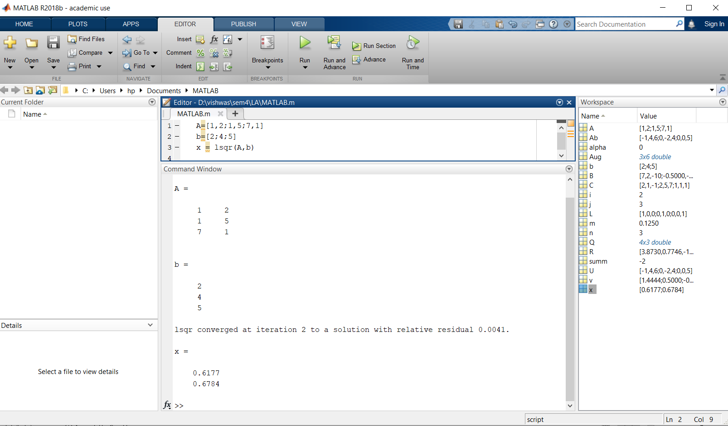

2) **least squares:**

i) Let onto and find P, the matrix that will project. any matrix onto the vector v. Use the result to find projv u.

u=[1;7]

v=[-4;2]

P=(v*transpose(v))/(transpose(v)*v)

P*u

Output:

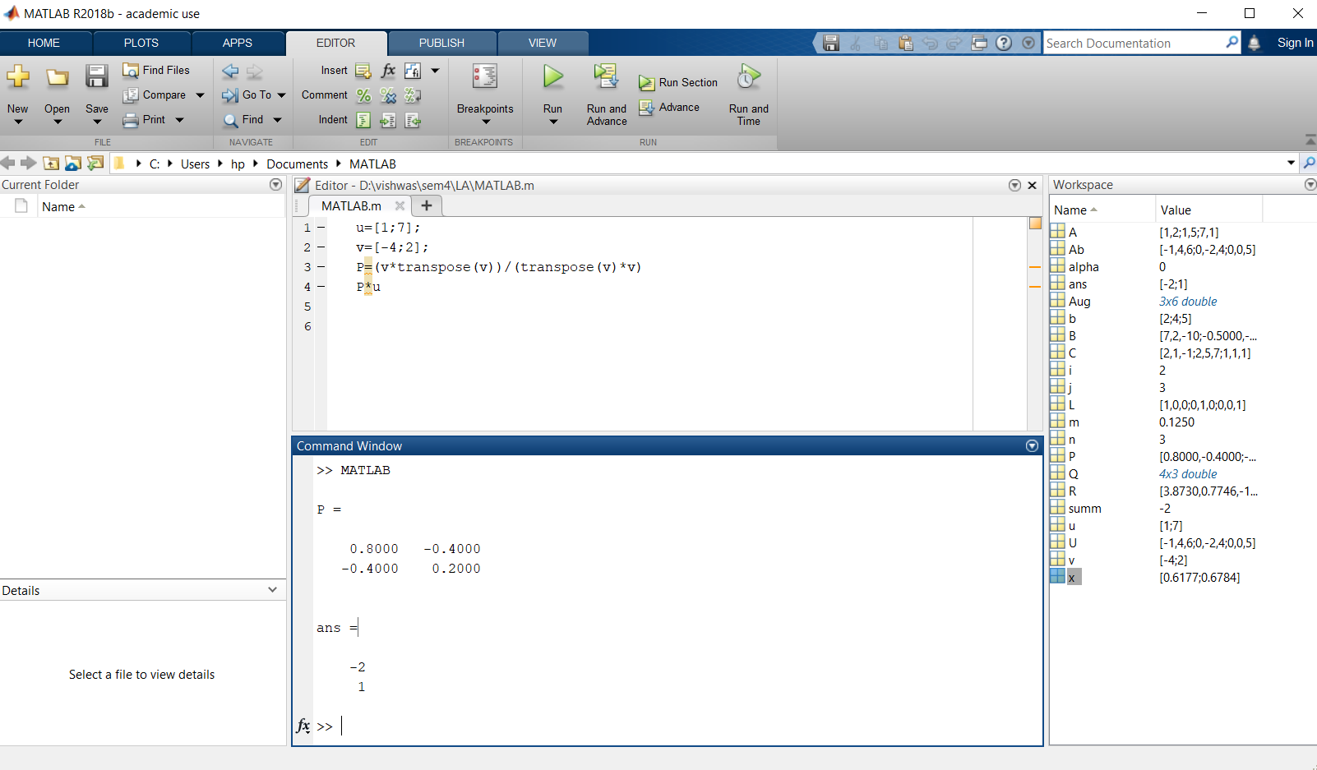

ii) Let onto and find P, the matrix that will project. any matrix onto the vector v. Use the result to find projv u.

u=[3;8];

v=[4;-2];

P=(v*transpose(v))/(transpose(v)*v)

P*u

Output:

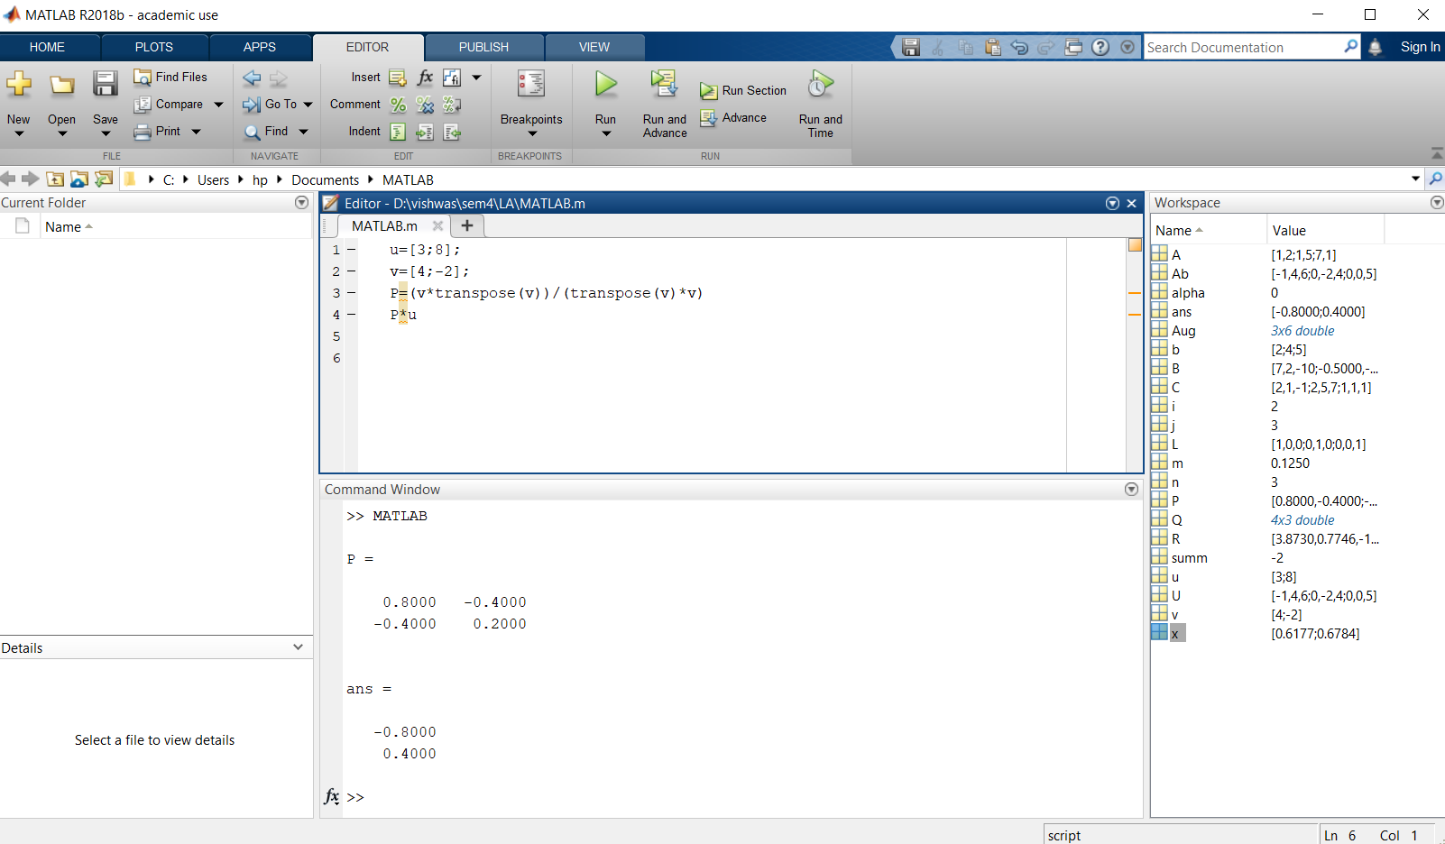

iii) Let onto and find P, the matrix that will project. any matrix onto the vector v. Use the result to find projv u.

u=[7;4];

v=[2;-8];

P=(v*transpose(v))/(transpose(v)*v)

P*u

Output:

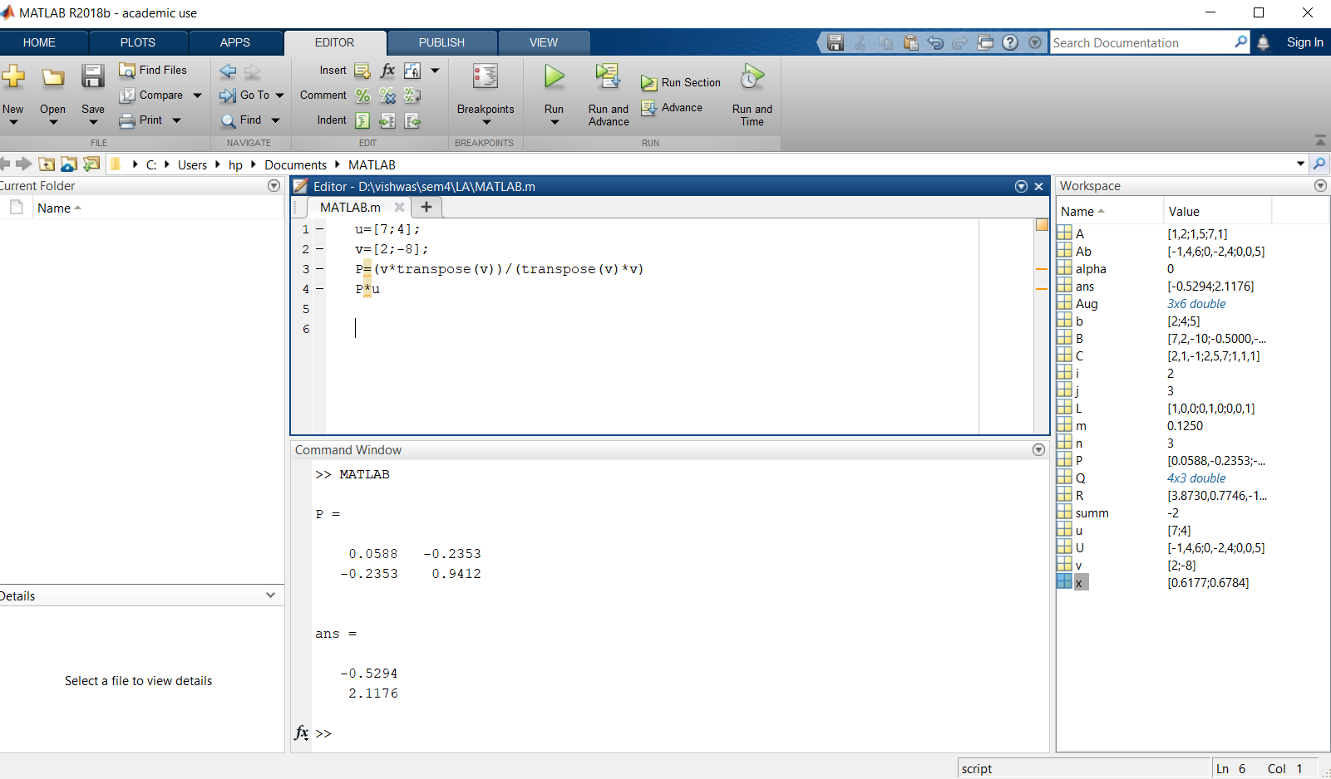

1. **Eigen values and Eigen vectors:**

i)Find the eigenvalues and the corresponding eigenvectors of the matrix A=[1,1,3;1,5,1;3,1,1].

Ans: A=[1,1,3;1,5,1;3,1,1]

e=eig(A)

det(A)

prod(eig(A))

sum(eig(A))

trace(A)

[V,D]=eig(A)

Output:

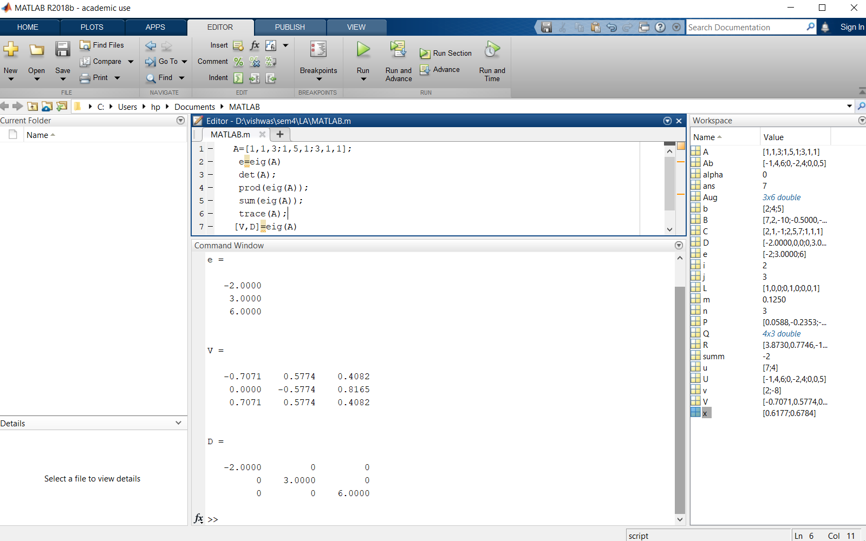

ii) Find the eigenvalues and the corresponding eigenvectors of the matrix

A=[2,3,1;6,1,2;3,6,3];

Ans: A=[2,3,1;6,1,2;3,6,3];

e=eig(A)

det(A);

prod(eig(A));

sum(eig(A));

trace(A);

[V,D]=eig(A)

Output:

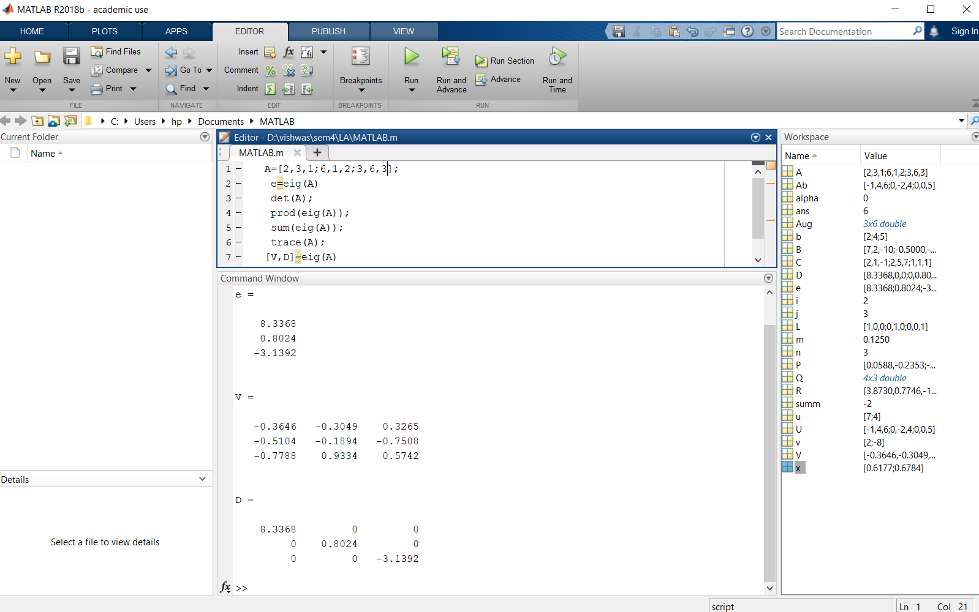

iii) Find the eigenvalues and the corresponding eigenvectors of the matrix

A=[5,2,1;9,1,5;2,0,3];

Ans: A=[5,2,1;9,1,5;2,0,3];

e=eig(A)

det(A);

prod(eig(A));

sum(eig(A));

trace(A);

[V,D]=eig(A)

Output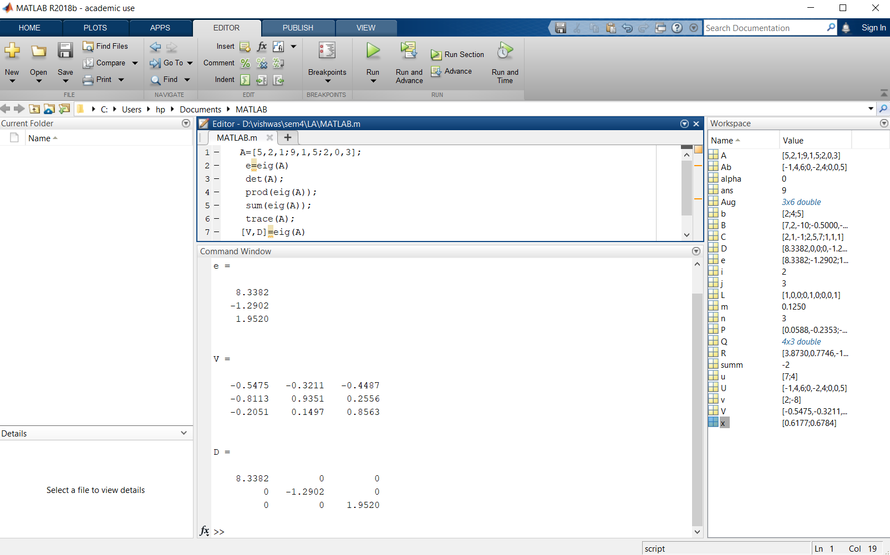

1. **QR Decomposition with Gram-Schmidt:**

i) Find QR factorization of the matrix

A=[1,1,0;1,0,1;0,1,1]

[Q,R]=qr(A)

Output:

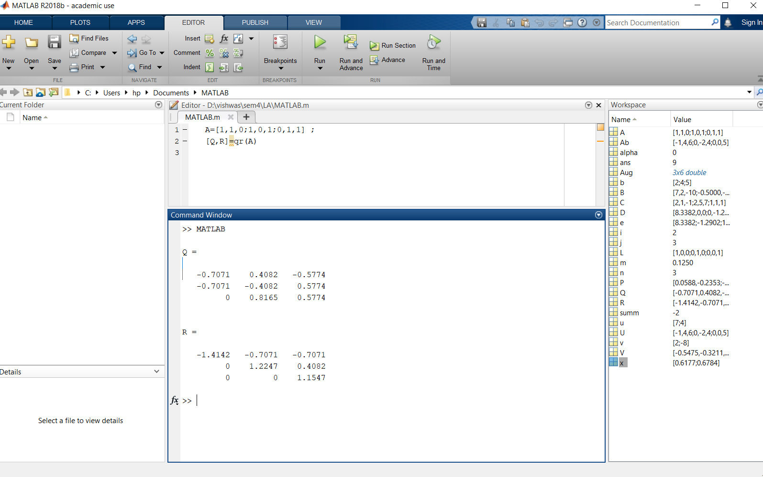

ii) Find QR factorization of the matrix

A=[1,-1,4;1,4,-2]

[Q,R]=qr(A)

Output:

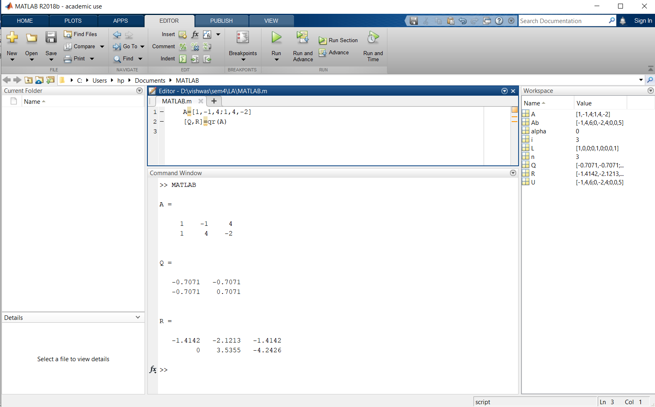

iii) Find QR factorization of the matrix

A=[3,2,4;2,0,2;4,2,3]

[Q,R]=qr(A)

Output:

